AI Multi-Agent System for Hospital Insurance Revenue Cycle Management (RCM) with HCX Integration
Implementation-Ready Architecture & Delivery Plan — Provider-side RCM intelligence riding HFCX rails (Egypt context)
May 2026

Contents
- Assumptions
- 1. Executive Summary
- 2. RCM Process Decomposition & Pain Points
- 3. Multi-Agent Architecture
- 4. Per-Agent Specifications
- 5. HCX Integration Design
- 6. Data & Interoperability Layer
- 7. Technology Stack & Infrastructure
- 8. Security, Privacy & Compliance (Egypt regime)
- 9. AI Governance, Safety & Human Oversight
- 10. Observability, Evaluation & Guardrails
- 11. HIS/EHR & Workflow Integration
- 12. Implementation Roadmap & Phasing
- 13. KPIs & Success Metrics
- 14. Cost / ROI Model
- 15. Risks & Mitigations
- 16. Team & RACI
- 17. Appendices
- Three clarifying questions (answers would most change this design)

Assumptions
The master prompt’s VARIABLES were left generic, so this plan is grounded against the most likely operating context and flagged accordingly. Adjust the three clarifying questions at the end to retune.
Variable | Assumed value used in this plan
HOSPITAL_PROFILE | 300-bed tertiary hospital, ~12,000 claims/month, mixed inpatient + outpatient, single legal entity with 4–6 outpatient feeder clinics.
COUNTRY / REGULATORY | Egypt. NHIA (Universal Health Insurance), EDA (drug/device), FRA (private insurance), CBE (payment settlement), Egyptian Medical Syndicate, MOHP, GAHAR accreditation.
EXISTING_HIS_EHR | Heterogeneous estate: a primary HIS (Nice Deer / DMS / Khabeer class) plus an OpenEMR/Bahmni reference deployment. Integration is read-mostly via FHIR + DB/event taps.
PAYER_MIX | 45% NHIA (national, growing), 40% private insurers (FRA-regulated TPAs), 15% self-pay.
HCX_GATEWAY | HFCX — HealthFlow Claims Exchange, localized for Egypt: FHIR R4 payloads, JWE payload protection, participant registry (HPR), decentralized exchange protocol, async callbacks.
CLAIM_STANDARDS_IN_USE | FHIR R4 claim bundles as the primary rail (HFCX-native); X12 837/835/270/271/278 and proprietary payer portals treated as edge adapters for legacy private TPAs.
AUTONOMY_TARGET | Human-in-the-loop (propose-only) for all submissions in Phase 1 → selective auto-submit of clean claims under hard guardrails by Phase 3.
DEPLOYMENT_PREFERENCE | DigitalOcean Kubernetes (DOKS), Frankfurt/Amsterdam region with Egypt data-residency mitigations; AI services as an additive namespace alongside the existing HFCX Java/Scala core.
TIMELINE / BUDGET | Assistive MVP in ~4 months; full phased rollout ~12–14 months. Indicative build envelope sized in Section 14.
Framing note. HFCX is the exchange / payer-facing rail and already carries an AI intelligence layer (hfcx-ai-claims: Eligibility, Medical Coding, Fraud, Medical Necessity agents on LangGraph). The system specified here is the provider-side counterpart — the hospital’s revenue-cycle brain — which consumes those rails rather than re-implementing them. Where an agent below mirrors an HFCX-side agent, they are deliberately distinct vantage points (hospital net-collection optimization vs. exchange adjudication intelligence) and share patterns, not state.

1. Executive Summary
Hospitals leak revenue at every seam of the claims lifecycle: eligibility checked too late, charges never captured, codes that fail payer edits, denials that are never worked, and remittances posted without variance checks against contracted rates. In an Egyptian provider running ~12k claims/month, even a 6–8% denial rate and a 10% under-capture on coding translate into millions of EGP of recoverable or never-collected revenue annually, with AR days dragging cash flow.
This plan specifies an additive AI multi-agent system that sits over the hospital’s existing HIS/EHR and rides the HFCX exchange rails. A LangGraph supervisor orchestrates twelve specialized agents that verify eligibility, secure prior authorization, code and scrub claims, submit over HFCX (FHIR R4 / JWE), classify and appeal denials, post and reconcile remittances against contracts, estimate patient responsibility, and continuously flag fraud/medical-necessity issues — every one of them carrying a rationale and a confidence signal, and every financial or clinical action gated by a human until metrics justify narrow autonomy. The headline outcomes the design targets: clean-claim rate 78% → 94%+, denial rate 8% → ≤4%, denial overturn 35% → 60%+, and AR days 62 → ≤40, while cutting biller/coder touch-time per claim by roughly half.
The build approach is standards-first and phase-gated: FHIR R4 and the HCX protocol are the primary contract; X12 and payer portals are edge adapters; agents start read-only and assistive (Phase 1), gain HFCX-driven submission and denial automation under human approval (Phase 2), and earn selective autonomy for narrowly-defined clean claims only after eval gates are met (Phase 3). Nothing financial or clinical happens silently.

2. RCM Process Decomposition & Pain Points
The revenue cycle is decomposed below stage by stage. “Leakage” = revenue lost or delayed; “AI leverage” = where agency moves the needle most.
# | Stage | Current manual pain points | Primary leakage point | Where AI agency adds most value
1 | Patient access / registration | Demographic & ID typos; duplicate MRNs; missing payer/policy fields | Downstream denials from registration errors (~25% of all denials) | Real-time validation of National ID + policy data at the desk; duplicate detection
2 | Eligibility & benefits | Checked late or not at all; manual portal logins per payer | Services rendered to ineligible/exhausted-benefit patients | Eligibility Agent runs HFCX coverage check at scheduling and at service; surfaces coverage, copay, exclusions
3 | Prior authorization | Slow, fax/portal-bound; missed auths cause hard denials | Non-auth denials are largely non-appealable = pure loss | Prior-Auth Agent detects auth-required services from orders, drafts/submits HFCX pre-auth, tracks status
4 | Charge capture | Services rendered but never charged (esp. supplies, procedures, OR time) | Silent under-billing — invisible because it never enters the claim | Charge-Integrity Agent reconciles orders/EHR events vs. charge lines; flags missing/under-coded charges
5 | Medical coding | Manual ICD-10/CPT; backlog (DNFB); under- and mis-coding | Under-coding (lost legitimate revenue) and over-coding (compliance risk) | Coding Agent proposes ICD-10/CPT/SNOMED/LOINC with confidence + rationale from documentation
6 | Claim scrubbing | Generic scrubbers miss payer-specific edits; rework loops | Rejections before adjudication; resubmission delay | Scrubbing Agent applies payer-rule RAG + NHIA/EDA edits pre-submission for clean-claim lift
7 | Submission | Multiple portals/formats; batch lag; no idempotency discipline | Lost/duplicate claims, batch failures | Submission Agent packages FHIR Claim, submits over HFCX with idempotency keys + callbacks
8 | Adjudication tracking | Black box after submission; no proactive status | Aging claims silently stall | Supervisor + Submission Agent poll/await HFCX ClaimResponse; auto-escalate stalls
9 | Remittance / payment posting | Manual posting; rarely checked vs. contract | Underpayments accepted as paid-in-full | Reconciliation Agent parses PaymentNotice/835, detects variance vs. contracted fee schedule
10 | Denial management & appeals | Denials triaged late; many never worked; weak appeals | The single largest recoverable bucket | Denial Agent classifies, root-causes, drafts evidence-backed appeals, manages resubmission
11 | Patient responsibility & collections | Surprise balances; poor estimates; slow statements | Bad debt; abandoned self-pay | Patient-Billing Agent estimates responsibility up front, generates statements & reminders
12 | Reporting / analytics | Lagging spreadsheets; no root-cause loop | Decisions made blind; pain recurs | Analytics Agent computes KPIs, narrates trends, feeds root-cause back to upstream agents
Cross-cutting leakage the design also targets: contract-rate drift (payer pays below contracted rate), timely-filing limit breaches, bundling/unbundling errors, and DNFB (discharged-not-final-billed) backlog.

3. Multi-Agent Architecture

3.1 Agent roster (12 agents + supervisor)
The roster maps 1:1 onto the leakage points above. Two pairs are deliberately kept separate rather than merged and the rationale is given; the rest are atomic.
Agent | Kept / merged | Rationale
Orchestrator / Supervisor | Singleton | Owns workflow state, routing, escalation; not a domain agent.
Eligibility & Benefits | Atomic | High call volume, distinct HFCX flow, runs at two trigger points.
Prior Authorization | Atomic | Different FHIR resource set (Claim with use=preauthorization), distinct SLA.
Medical Coding | Atomic | Highest clinical-safety stakes; needs its own eval harness and HITL bar.
Charge Capture & Charge-Integrity | Kept separate from Coding | Coding answers “what was done, in code”; charge integrity answers “was everything that was done actually billed”. Different inputs (orders/inventory vs. documentation) and different failure mode (omission vs. miscode). Merging hides charge omissions inside coding confidence.
Claim Scrubbing & Submission | Merged | Scrubbing is the immediate gate before submission; tight coupling, shared payer-rule context, one state handoff. Merging avoids a redundant hop.
Denial Management & Appeals | Atomic | The ROI center; needs deep RAG over denial reasons + appeal evidence.
Payment Posting & Reconciliation | Atomic | Touches financial ledger; variance detection is its own discipline.
Patient Billing & Collections | Atomic | Patient-facing comms, different tone/consent rules.
Fraud, Waste & Medical-Necessity | Atomic | Runs as a cross-cutting sentinel over coding/charge/claim outputs, not in the linear path.
Payer-Contract & Rules | Knowledge-service agent | Not in the linear flow; a queryable RAG/service that other agents consult (fee schedules, contract terms, payer edits).
Analytics & Reporting | Atomic | Read-only over the event store; produces KPIs and the improvement loop.

3.2 Orchestration pattern
Pattern: hybrid supervisor + graph handoffs (LangGraph). A central supervisor owns the canonical claim state and routes work, but the linear “happy path” (eligibility → … → submission) is expressed as a graph with conditional edges, so an agent can hand directly to the next without a supervisor round-trip on the common path. The supervisor intercepts only on branch points (denial, low confidence, escalation, retry). The Fraud/Necessity sentinel and the Contract/Rules knowledge service are out-of-band: invoked as tools/subscribers rather than path nodes.
Why LangGraph (vs. a pure router or autogen-style free chat): - Explicit, inspectable state graph — every transition is a named edge, which is exactly what auditors and the “no silent action” principle demand. - Durable checkpointing — long-running claims (pre-auth, appeals can take days) need persisted state across restarts; LangGraph checkpointers map to Postgres/Redis. - Deterministic interrupts — interrupt() cleanly models human-in-the-loop approval gates without bespoke plumbing. - Reuse — it matches the existing hfcx-ai-claims orchestration, so patterns, tracing, and ops carry over.

3.3 Agent topology
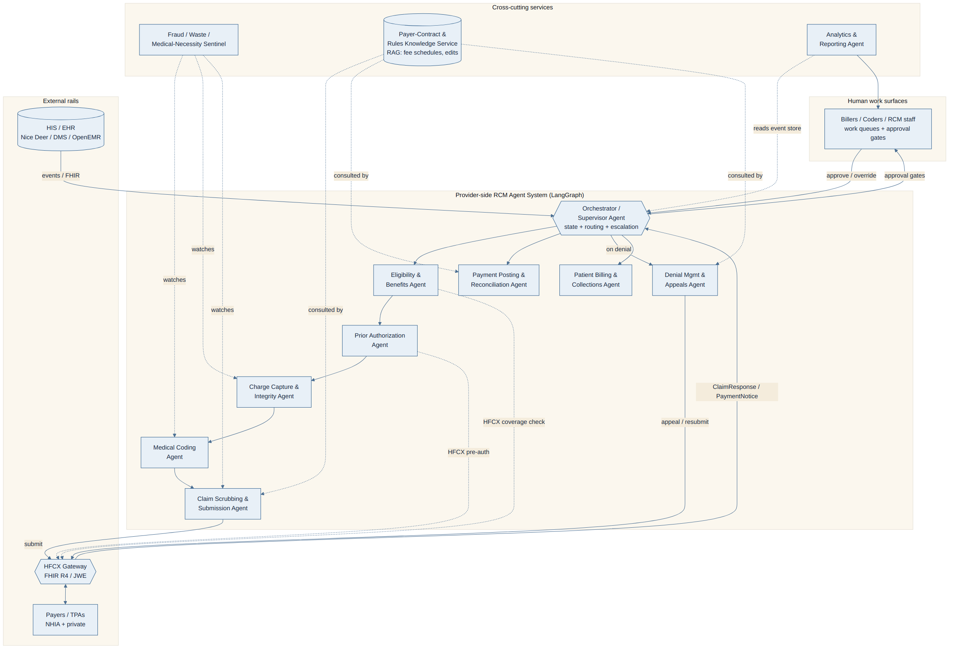
Figure 1 — Multi-agent topology and orchestration

4. Per-Agent Specifications
Each agent below lists purpose, trigger, inputs/outputs, tools, knowledge (RAG), guardrails, confidence threshold, and the human-in-the-loop (HITL) escalation rule. Thresholds are starting values to be tuned against the eval harness (Section 10).

4.1 Orchestrator / Supervisor
- Purpose: Own canonical claim state; route between agents; enforce approval gates; handle retries, timeouts, escalation.
- Trigger: New encounter/claim event from HIS; any agent callback; HFCX async callback.
- Inputs: Claim state object (§17.4), agent results, human decisions.
- Outputs: Next-node routing, work-queue items, audit events.
- Tools/APIs: LangGraph state store, Kafka producer/consumer, Keycloak (actor identity).
- Guardrails: Cannot itself take financial/clinical action — only routes. Every transition writes an immutable audit event.
- HITL: Escalates on any agent confidence below its gate, conflicting agent outputs, or SLA breach.

4.2 Eligibility & Benefits Agent
- Purpose: Verify coverage, benefits, copay/coinsurance, exclusions, accumulators.
- Trigger: At scheduling and again at point-of-service; re-check if >72h stale.
- Inputs: Patient National ID, payer/policy, planned service codes.
- Outputs: Coverage status, benefit detail, patient-responsibility estimate seed, exclusion flags.
- Tools/APIs: HFCX CoverageEligibilityRequest/Response; X12 270/271 adapter for legacy TPAs.
- RAG: Payer benefit grids, NHIA coverage rules.
- Guardrails: Never asserts coverage on a stale/failed check — returns unknown not eligible.
- Confidence: ≥0.90 to mark eligible without review.
- HITL: Ineligible/exhausted, payer mismatch, or any unknown → desk/biller review before service where elective.

4.3 Prior Authorization Agent
- Purpose: Detect auth-required services, assemble clinical justification, submit and track pre-auth.
- Trigger: Order/scheduling of a service on the payer’s auth-required list.
- Inputs: Order, diagnosis, clinical notes, payer auth rules.
- Outputs: Auth determination need, drafted pre-auth packet, auth number/status.
- Tools/APIs: HFCX Claim(use=preauthorization) + ClaimResponse; X12 278 adapter; CommunicationRequest for additional-info loops.
- RAG: Payer auth lists, medical-necessity criteria.
- Guardrails: Cannot submit auth without minimum clinical evidence set; flags missing documentation rather than fabricating.
- Confidence: ≥0.85 on “auth required?” classification; submission packet always human-approved in Phases 1–2.
- HITL: Always surfaces packet for clinician/auth-coordinator sign-off pre-submission; auto-resubmits only status polls.

4.4 Medical Coding Agent
- Purpose: Propose ICD-10, CPT/procedure, HCPCS-equiv, SNOMED CT, LOINC from documentation with rationale + confidence.
- Trigger: Encounter documentation finalized / DNFB queue.
- Inputs: Clinical notes, problem list, orders, results, procedure logs.
- Outputs: Ranked code set with span-level evidence citations and per-code confidence.
- Tools/APIs: Terminology service (ICD-10, CPT, SNOMED, LOINC); EDA drug mapping; ICD-10 lookup connector.
- RAG: Official coding guidelines, NCCI-equivalent edits, specialty coding rules, Arabic clinical NLP (AraBERT/BiMediX) for Arabic notes.
- Guardrails: Each code must cite supporting documentation span; no code without evidence; explicit “documentation insufficient” path.
- Confidence: ≥0.92 per code to auto-accept (Phase 3 only); below → coder review with suggestions.
- HITL: All codes coder-reviewed in Phases 1–2; high-impact/high-DRG codes always reviewed.

4.5 Charge Capture & Charge-Integrity Agent
- Purpose: Reconcile services rendered (orders, MAR, OR logs, implants/supplies) against charge lines; catch omissions and under-charges.
- Trigger: Pre-bill, after coding, before scrubbing.
- Inputs: Order/EHR event stream, inventory/pharmacy issue, charge master (CDM), coded claim draft.
- Outputs: Missing-charge list, under-charge flags, reconciled charge set with rationale.
- Tools/APIs: CDM lookup, inventory/pharmacy API, HIS order feed.
- RAG: Charge master, bundling rules.
- Guardrails: Proposes charges only with a traceable service event; never invents services.
- Confidence: ≥0.88 to auto-add a missing charge (Phase 3); else flag.
- HITL: Any added charge above EGP threshold or implant/high-cost item → biller confirm.

4.6 Claim Scrubbing & Submission Agent (merged)
- Purpose: Apply payer-specific + national edits, confirm clean-claim criteria, package FHIR Claim, submit over HFCX with idempotency, await response.
- Trigger: Coded + charge-reconciled claim.
- Inputs: Final claim draft, payer rules, timely-filing windows.
- Outputs: Pass/fail scrub report; submitted FHIR Claim bundle; HFCX correlation id; ClaimResponse.
- Tools/APIs: HFCX Claim/ClaimResponse; X12 837 adapter; scrubber rule engine; idempotency-key store.
- RAG: Payer edit libraries, NHIA/FRA formatting rules.
- Guardrails: Will not submit a claim failing a hard edit; idempotency key prevents duplicate submission; timely-filing guard.
- Confidence: Clean-claim score ≥0.95 to auto-submit (Phase 3, eligible claim classes only).
- HITL: All submissions approved in Phases 1–2; any hard-edit failure always returned to biller.

4.7 Denial Management & Appeals Agent
- Purpose: Classify denials (CARC/RARC-equiv + payer reasons), root-cause, draft evidence-backed appeals, manage resubmission and timely-appeal windows.
- Trigger: Denied/partially-denied ClaimResponse or remittance adjustment.
- Inputs: Denial reason, original claim, clinical evidence, contract terms, prior similar-denial outcomes.
- Outputs: Denial category, root cause, recoverability score, drafted appeal letter + evidence bundle, or write-off recommendation.
- Tools/APIs: HFCX resubmission/CommunicationRequest; document assembly; contract service.
- RAG: Denial-reason taxonomy, won-appeal corpus, payer policy bulletins.
- Guardrails: Never auto-files an appeal that asserts unsupported facts; cites evidence; respects appeal deadlines.
- Confidence: Appeal drafted always; auto-file only for templated low-risk categories (Phase 3) at ≥0.90.
- HITL: Appeals reviewed by denial specialist; write-offs always human-approved.

4.8 Payment Posting & Reconciliation Agent
- Purpose: Parse remittance, post payments, detect variance vs. contracted rate, flag underpayments and unexpected adjustments.
- Trigger: HFCX PaymentNotice / X12 835 receipt.
- Inputs: PaymentNotice/835, original claim, contracted fee schedule.
- Outputs: Posting instructions, variance report, underpayment work items.
- Tools/APIs: HFCX PaymentNotice; X12 835 adapter; ledger API; contract service.
- RAG: Contracted fee schedules.
- Guardrails: Posting is propose-only to the financial ledger until human/finance confirm in Phases 1–2; variances above threshold always surfaced.
- Confidence: Exact contract-match auto-posts (Phase 3); any variance → review.
- HITL: Underpayment beyond tolerance, contractual adjustment disputes → finance.

4.9 Patient Billing & Collections Agent
- Purpose: Estimate patient responsibility, generate statements, sequence respectful reminders, surface financial-assistance/installment options.
- Trigger: Adjudication complete with patient balance; or upfront estimate at scheduling.
- Inputs: Adjudicated amounts, benefit detail, patient contact/consent.
- Outputs: Estimate, statement, reminder cadence, payment-link (HealthPay where applicable).
- Tools/APIs: Statement/comms service (WhatsApp/SMS), HealthPay payment link.
- Guardrails: Respects communication consent and quiet hours; no aggressive/automated dunning; clear, non-coercive language.
- Confidence: Estimate band shown, not false precision.
- HITL: Disputes, hardship cases, and any write-down to human.

4.10 Fraud, Waste & Medical-Necessity Sentinel
- Purpose: Cross-cutting anomaly detection — upcoding, unbundling, impossible/duplicate services, medical-necessity gaps — before submission and on patterns over time.
- Trigger: Subscribes to coding, charge, and scrub outputs; periodic batch.
- Inputs: Coded claims, charge sets, historical patterns, necessity criteria.
- Outputs: Risk flags with rationale, blocking vs. advisory severity.
- Tools/APIs: Anomaly models, necessity-criteria service.
- RAG: Necessity guidelines, fraud-pattern library.
- Guardrails: Flags, does not silently alter claims; a high-severity flag blocks auto-submission and forces human review.
- HITL: High-severity → compliance officer; advisory → biller note.

4.11 Payer-Contract & Rules Knowledge Service
- Purpose: Authoritative, queryable source of fee schedules, contract terms, payer-specific edits and auth lists for all other agents.
- Trigger: On-demand tool call.
- Inputs: Payer id, service code, date of service.
- Outputs: Contracted rate, edit set, auth requirement, timely-filing window.
- Guardrails: Versioned, effective-dated; returns provenance for every rule.
- HITL: Contract ingestion/changes reviewed by RCM SME before activation.

4.12 Analytics & Reporting Agent
- Purpose: Compute KPIs, narrate trends for finance leadership, feed root-cause insights back to upstream agents.
- Trigger: Scheduled + on-demand.
- Inputs: Event store (read-only).
- Outputs: KPI dashboards, narrative briefs, root-cause feedback signals.
- Guardrails: Read-only; no PHI in narrative exports beyond need; figures traceable to source events.
- HITL: None for reads; recommendations are advisory.

5. HCX Integration Design
HFCX is a - protocol exchange. The provider-side agents are an HCX participant registered in the Health Provider Registry (HPR); every exchange is an asynchronous, JWE-protected FHIR R4 payload with a protocol envelope and a callback. The four core flows:

5.1 Common protocol mechanics (apply to all flows)
- Participant lookup: Resolve sender/recipient via HPR before any send; cache with TTL.
- Payload protection: FHIR resource → FHIR Bundle → JWE (encrypted to recipient’s public key) → wrapped in the HCX protocol envelope (headers: x-hcx-sender_code, x-hcx-recipient_code, x-hcx-correlation_id, x-hcx-api_call_id, x-hcx-timestamp, x-hcx-status).
- Async pattern: Sender POSTs to the recipient’s HCX /submit endpoint and receives an HTTP 202 Accepted. The actual business response arrives later as an inbound POST to the sender’s /on_* callback endpoint, correlated by correlation_id.
- Idempotency: api_call_id is unique per attempt; correlation_id is stable across the request/response pair. The Submission Agent persists (correlation_id, claim_id) so retries never double-submit.
- Error/retry: 202 only acknowledges receipt. Protocol errors return HCX error codes; business errors arrive in the callback’s ClaimResponse.outcome/error. Retry with exponential backoff on transport failures; never retry a business denial as if it were a transport error.

5.2 The four flows and their FHIR R4 resources
Flow | Request resource(s) | Response resource(s) | Driven by | Callback
Coverage eligibility | CoverageEligibilityRequest, Coverage, Patient | CoverageEligibilityResponse | Eligibility Agent | /on_check
Pre-authorization | Claim(use=preauthorization), Coverage, Condition, ServiceRequest | ClaimResponse(use=preauthorization) | Prior-Auth Agent | /on_submit
Claim submission | Claim(use=claim), Encounter, Procedure, Coverage, Organization, Practitioner | ClaimResponse(use=claim); optional CommunicationRequest for additional info | Scrubbing & Submission Agent | /on_submit, /on_communication
Payment notice / remittance | PaymentNotice (and reconciliation context) | PaymentReconciliation / PaymentNotice ack | Reconciliation Agent | /on_payment
CommunicationRequest / Communication handle the “payer needs more documentation” loop for both pre-auth and claims — the Prior-Auth and Denial agents own those responses.

5.3 Sequence — Coverage eligibility
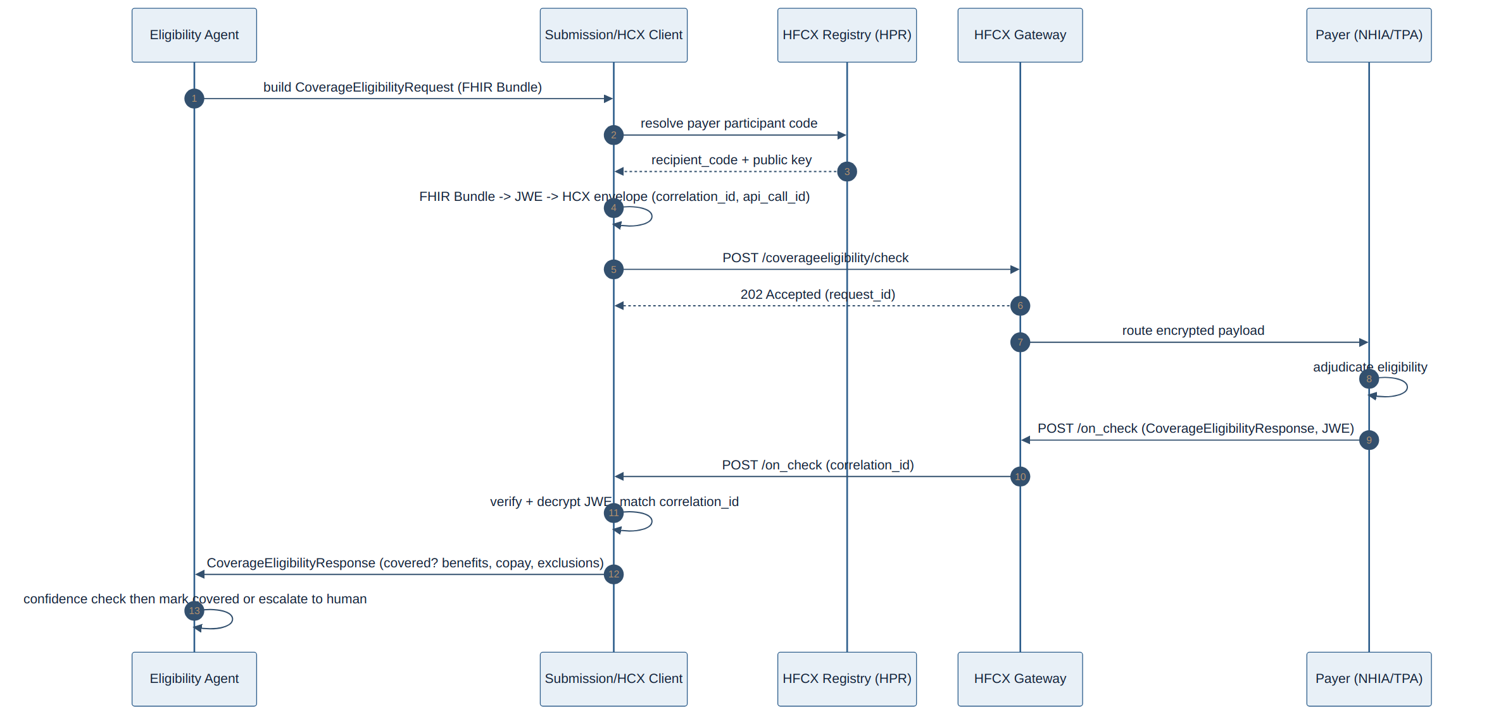
Figure 2 — Coverage eligibility sequence (Agent to HFCX to Payer)

5.4 Sequence — Claim submission & adjudication
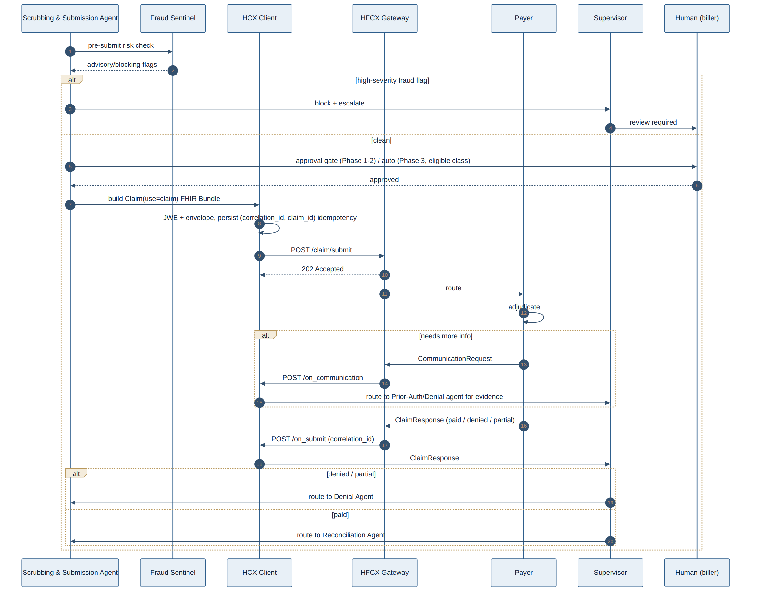
Figure 3 — Claim submission & adjudication sequence

5.5 Error, retry & idempotency rules
- Transport failure / no 202: retry with backoff (e.g., 1s, 4s, 15s, then dead-letter to a human queue). Same api_call_id reused only within a bounded retry window; a new attempt gets a new api_call_id but the same correlation_id.
- Duplicate callback: callbacks are deduplicated on correlation_id + resource hash; second arrival is logged and ignored.
- Stale claim: if no callback within the payer SLA, Supervisor raises an aging-claim work item rather than blindly resubmitting.
- Decryption/verification failure: never processed; routed to security incident queue.

6. Data & Interoperability Layer

6.1 Canonical internal model
A single canonical claim graph is the agents’ shared truth, normalized away from any one HIS/EHR dialect. Core entities: Patient, Coverage, Encounter, ServiceLine (order → charge → code), ClaimDraft, ClaimSubmission, Adjudication, Remittance, Denial, Appeal, PatientBalance. Each carries provenance (source system, timestamp, responsible actor) and an evidence[] array linking back to source documentation spans.

6.2 Mapping strategy (three-layer)
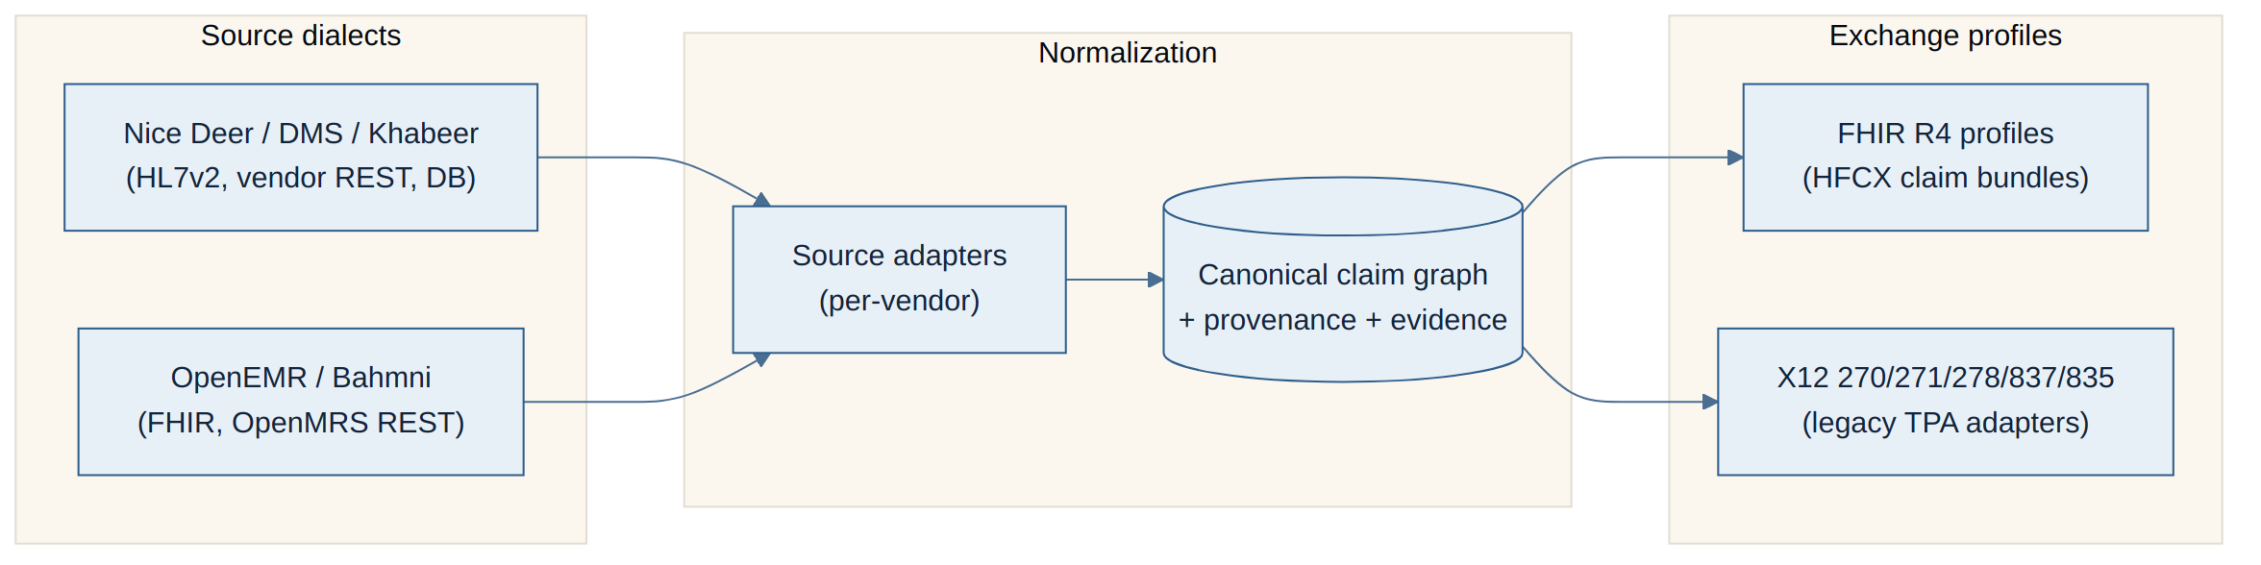
Figure 4 — Three-layer data normalization & mapping - Inbound: vendor adapters translate HL7v2 / vendor REST / OpenMRS-FHIR into the canonical graph. - Outbound: the canonical graph renders to FHIR R4 HFCX profiles (primary) or X12 (legacy TPA edge). FHIR is the contract; X12 is an adapter, never the internal model.

6.3 Terminology services
A central terminology service backs the Coding Agent and validates every code on the canonical graph: - ICD-10 (and ICD-10-AM/local Egyptian variants where mandated by NHIA), CPT/procedure, HCPCS-equivalent, SNOMED CT, LOINC (labs), EDA drug dictionary mapping for medications. - Exposed as a tool (/terminology/validate, /terminology/lookup, /terminology/crosswalk) with effective-dating and value-set binding. Arabic ↔ English term resolution uses the Arabic clinical NLP stack (AraBERT/BiMediX) for free-text Arabic notes.

6.4 Normalization guarantees
Clinical and financial data are reconciled into one timeline per encounter so the Charge-Integrity and Coding agents see the same set of events. No agent acts on a source dialect directly — only on the canonical graph — which keeps adapters swappable as the HIS estate changes.

7. Technology Stack & Infrastructure
Layer | Choice | Notes
Agent orchestration | Python + LangGraph | Matches existing hfcx-ai-claims; durable checkpoints in Postgres; interrupt() for HITL gates.
Model strategy | Tiered | Frontier reasoning model (e.g., Claude class) for coding rationale, denial appeals, ambiguous reasoning; smaller/fine-tuned models for classification (denial category, auth-required, eligibility parse); deterministic rule engine for hard payer edits. Route by task, not one-model-fits-all.
Clinical NLP | AraBERT / BiMediX, Bio_ClinicalBERT-class | Arabic + English documentation understanding, DDI, ICD assist (reuse of existing ai-engine assets).
Vector store | pgvector or Qdrant | RAG corpora: payer rules, coding guidelines, contracts, won-appeal library.
Message bus | Kafka / Redpanda | Agent events as topics: rcm.eligibility, rcm.coding, rcm.charge, rcm.scrub, rcm.submission, rcm.adjudication, rcm.denial, rcm.remittance, rcm.audit. Same backbone as HFCX integration.
Operational DB | PostgreSQL (+ TimescaleDB for KPI time-series) | Canonical graph, claim state, audit log.
Hot state / cache | Redis | Eligibility cache, idempotency keys, LangGraph short-term checkpoints.
Identity / access | Keycloak | Actor identity for every action (agent service accounts + human users), OIDC, RBAC.
HCX client | Reused HFCX participant SDK | JWE, envelope, callbacks, HPR lookup.
Deployment | DigitalOcean Kubernetes (DOKS) | AI services as an additive namespace beside the HFCX Java/Scala core; never in the core’s critical path.
Observability | LangSmith/OpenTelemetry + Prometheus/Grafana | Multi-agent run tracing + infra metrics.
Where AI sits: the AI agents are an additive layer. They read from HIS and HFCX, write proposals and audit events, and call HFCX for exchange — but the system of record for money remains the hospital’s ledger/HIS, and the exchange rail remains HFCX. The AI namespace can be disabled without stopping claims from flowing manually.

8. Security, Privacy & Compliance (Egypt regime)
Domain | Control | Mapped authority
PHI / personal data | Egypt Personal Data Protection Law (151/2020): lawful basis, minimization, patient consent for comms, data-subject rights. | PDPL / MOHP
Data residency | Primary data and audit store kept in-Egypt where feasible; where DOKS region is EU, apply contractual + encryption mitigations and a residency review. | PDPL
Encryption in transit | TLS 1.2+ everywhere; JWE payload protection end-to-end for all HFCX exchanges (defense beyond transport). | HCX protocol
Encryption at rest | DB + object storage encryption; key management via KMS; field-level encryption for identifiers. | PDPL / good practice
Audit logging | Every agent decision logged: inputs, RAG sources used, reasoning summary, output, confidence, model/version, responsible human, timestamp — immutable, append-only. | Auditability principle
Access control | Keycloak RBAC; least privilege; separate service accounts per agent; human roles (coder, biller, denial specialist, compliance, finance) scoped to their queues. | PDPL / GAHAR
Payments / PCI | Patient payments via HealthPay (CBE-licensed) keep card data out of scope of the RCM system (PCI DSS SAQ-D boundary stays with the payment processor); RCM stores tokens/refs only. | CBE / PCI DSS
AML/CFT | Where settlement flows touch HealthPay, AML/CFT screening is the payment system’s responsibility; RCM passes references, not raw financial instruments. | CBE Law 194/2020
Regulatory edits | NHIA claim rules, EDA drug coding, FRA private-insurer formatting enforced in the rules service and scrubber. | NHIA / EDA / FRA
Clinical accreditation | Coding/necessity workflows align to GAHAR documentation standards. | GAHAR
Principle: the RCM system handles clinical and claims PHI but deliberately does not hold cardholder data and does not perform settlement — those stay inside HealthPay/CBE scope, sharply narrowing PCI and AML exposure.

9. AI Governance, Safety & Human Oversight

9.1 Decision-authority matrix
“Autonomous” means an agent may execute without per-instance approval once the phase gate is met; until then everything high-impact is propose-only.
Action | Phase 1 | Phase 2 | Phase 3 (gated)
Eligibility check (read) | Auto | Auto | Auto
Mark patient eligible | Propose | Propose | Auto if conf ≥0.90
Submit pre-auth | Propose | Propose | Propose (always)
Assign medical codes | Propose | Propose | Auto per-code ≥0.92 (low-risk classes)
Add missing charge | Propose | Propose | Auto ≤ EGP threshold
Submit clean claim | Propose | Approve-before-execute | Auto for eligible class, clean-score ≥0.95
File appeal | Propose | Approve | Auto for templated low-risk ≥0.90
Post payment to ledger | Propose | Approve | Auto on exact contract match
Write off / adjust | Propose | Propose | Propose (always human)
Patient dunning escalation | Propose | Approve | Approve

9.2 Operating principles
- No silent financial or clinical action. Anything touching money owed or clinical codes is at minimum auditable and reversible; high-impact actions are approve-before-execute until metrics justify narrow autonomy.
- Explainability mandatory. Every recommendation carries a rationale + confidence + evidence citations the human can inspect inline.
- Fail safe, not silent. On low confidence/ambiguity, escalate — never guess.
- Reversibility. Auto actions in Phase 3 are bounded to reversible/low-blast-radius classes and are continuously monitored.

9.3 Override → improvement loop
Human overrides are first-class events: captured with reason codes, fed to the Analytics Agent and the eval set, and used to (a) retune confidence thresholds, (b) expand RAG corpora (e.g., a new won-appeal pattern), and (c) flag agents/classes that aren’t ready for autonomy. An agent’s autonomy for a claim class can only advance when its override rate on that class is below the gate.

10. Observability, Evaluation & Guardrails

10.1 Quality metrics per agent
- Coding Agent: code-level precision/recall vs. coder-final; over-/under-coding rate; documentation-insufficient detection.
- Scrubbing: clean-claim-rate uplift; false-block rate.
- Denial Agent: denial-classification accuracy; appeal win-rate; false “recoverable” rate.
- Eligibility: false-eligible rate (most dangerous), coverage-match accuracy.
- Fraud Sentinel: precision on flags (false-positive denial-flag rate is a tracked KPI).

10.2 Eval harness & golden cases
- Golden case library: de-identified historical encounters with known-correct codes, known adjudication outcomes, and known won/lost appeals. Versioned; expanded from overrides.
- Regression gate: no agent advances autonomy phase without passing its golden-case thresholds; CI runs evals on every prompt/model change.
- Shadow mode: before any autonomy, agents run in shadow against live claims and are scored against human outcomes.

10.3 Containment & tracing
- Hallucination/error containment: code/charge must cite evidence; “insufficient documentation” path is always available; hard rules sit in a deterministic engine, not the LLM.
- Tracing: every multi-agent run is traced end-to-end (LangSmith/OTel) with per-node inputs/outputs/confidence; auditors can replay a claim’s full reasoning.
- Drift monitoring: rolling accuracy and override-rate dashboards per agent/payer/claim-class; alert on degradation; payer-rule changes are change-events that trigger re-eval.
- Feedback loop: Section 9.3 overrides → eval set → threshold/RAG/model updates → re-gated.

11. HIS/EHR & Workflow Integration

11.1 Connection methods (read-mostly, write-narrow)
- FHIR endpoints where available (OpenEMR/Bahmni, modern HIS): pull Patient/Encounter/Condition/Procedure/Observation.
- HL7v2 feeds (ADT, ORM, ORU, DFT) where the HIS is older — consumed via an interface engine into the canonical graph.
- DB/event taps as a last resort for vendors without APIs (read replica + CDC), behind a vendor adapter.
- Writes are deliberately narrow: the system writes proposals, codes-for-review, and claim artifacts back through approved HIS APIs or to its own claim store; it does not silently mutate the clinical record.

11.2 Injection into existing workflows
- Coder workflow: Coding Agent suggestions appear as an inline panel in the coder’s existing queue — proposed codes, evidence spans, confidence — accept/edit/reject in one place; rejects are reason-coded.
- Biller workflow: scrub results and submission approvals surface as work-queue items with the claim, the flags, and a one-click approve (Phases 1–2).
- Denial specialist: prioritized denial queue ranked by recoverability × value, with a drafted appeal ready to edit.
- Finance: reconciliation variances as an exception queue; analytics narrative as a periodic brief.

11.3 UI surfaces
A thin RCM cockpit (React, Arabic/English RTL — consistent with the existing stack) over the agent system: dashboards (KPIs), work queues per role, agent-suggestion panels with rationale, audit/replay view, and approval gates. It augments — does not replace — the HIS where coders/billers already live; deep links keep them in flow.

12. Implementation Roadmap & Phasing
Phase | Scope | Agents activated | Success gate to advance | Rough effort
Phase 0 — Foundation | Canonical model, HIS adapters, terminology service, Keycloak, Kafka topics, audit store, HFCX participant onboarding (HPR), eval harness skeleton. | None (plumbing) | Data flows HIS→canonical→FHIR validated on golden cases; HFCX sandbox handshake works. | ~6–8 wks
Phase 1 — Assistive (read-only / propose-only) | Eligibility (read), Coding (propose), Charge-Integrity (propose), Analytics, Contract/Rules service. MVP. | ELIG, CODE, CHG, CONTRACT, ANALYTICS | Coder acceptance of suggestions ≥ target; measurable DNFB/coding-time reduction; zero silent writes. | ~6–8 wks (MVP ~4 mo cumulative)
Phase 2 — HCX submission + denial automation (human-approved) | Scrubbing & Submission over HFCX (approve-before-execute), Pre-Auth, Denial & Appeals (drafted), Reconciliation (propose), Fraud Sentinel (advisory→blocking), Patient Billing. | + SCRUB, AUTH, DENY, RECON, FRAUD, PAT | Clean-claim-rate uplift hits target in shadow+approved mode; appeal win-rate improves; false-eligible ≈ 0. | ~10–14 wks
Phase 3 — Selective autonomy (gated) | Auto-submit clean claims for eligible low-risk classes; auto-post exact-match remittances; auto-file templated low-risk appeals — each behind per-class eval gates and continuous monitoring. | Same roster, narrowed autonomy | Per-class override rate below gate over a sustained window; rollback tested. | Ongoing, class-by-class
Phasing is claim-class-granular in Phase 3: autonomy is earned per payer × service class, never globally switched on.

13. KPIs & Success Metrics
Baselines are illustrative for the assumed profile; replace with the hospital’s actuals. Measurement method noted for each.
KPI | Baseline | Target | How measured
Clean-claim rate | 78% | ≥94% | Claims passing all edits first time ÷ total submitted
First-pass acceptance | 82% | ≥95% | Accepted on first submission ÷ submitted
Denial rate | 8% | ≤4% | Denied lines ÷ adjudicated lines
Denial-overturn rate | 35% | ≥60% | Appeals won ÷ appeals filed
Days in AR | 62 | ≤40 | Net AR ÷ avg daily net revenue
Cost-to-collect | baseline | −30% | Total RCM cost ÷ collections
Net collection rate | 92% | ≥97% | Payments ÷ (charges − contractual adj.)
DNFB (days) | baseline | −50% | Discharged-not-final-billed value/days
Coding accuracy | baseline | ≥97% | Agent codes matching coder-final on audit sample
Charge-capture recovery | n/a | +X% revenue | Value of missing charges surfaced & billed
Agent automation rate | 0% | phase-dependent | Actions executed without per-instance human ÷ eligible actions
False-eligible rate | n/a | ≈0% | Eligible-marked later found ineligible (safety KPI)
False-positive denial flag | n/a | minimized | Fraud-flagged claims later found valid

14. Cost / ROI Model
Assumptions stated explicitly: 12,000 claims/month (144k/yr); average claim value and rates are placeholders the hospital must supply; figures below are an illustrative model, not a guarantee, and exclude payer-relationship and accreditation effects that take longer to realize.

14.1 Build & run cost (indicative envelope)
Item | Type | Indicative
Engineering build (orchestration, agents, adapters, cockpit) | One-time | Dominant capex; scales with HIS-adapter count
HFCX onboarding + terminology licensing | One-time + run | Per registry/terminology terms
Infra (DOKS, Postgres/Timescale, Kafka, Redis, vector store) | Run-rate | Cluster + managed DBs
LLM inference | Run-rate | Tiered routing keeps cost down — small models/rules for high-volume classification, frontier model only for reasoning-heavy coding/appeals
Model eval/ops + maintenance | Run-rate | Eval CI, drift monitoring, rule updates

14.2 Value case (the four recovery levers)
- Denial reduction: moving denial rate 8%→4% on 144k claims recovers a large share of previously-lost adjudicated value (denied lines that were valid).
- Denial recovery: overturn 35%→60% converts already-denied claims into collected revenue.
- Leakage / charge capture: surfacing missing charges adds net-new legitimate revenue invisible today.
- FTE-hours saved: ~50% reduction in coder/biller touch-time per claim redeployed to higher-value work (rather than headcount cuts).
ROI framing: even modest movement on levers 1–3 across 144k claims/yr typically dwarfs the run-rate cost; the build pays back primarily through denial reduction + leakage capture, with FTE efficiency as a secondary, softer benefit. The model should be re-run with the hospital’s real average claim value, denial value mix, and current FTE cost before any commitment.

15. Risks & Mitigations
L = Likelihood, I = Impact (H/M/L).
# | Risk | Category | L | I | Mitigation
1 | Incorrect coding (over/under) | Clinical-safety / compliance | M | H | Evidence-cited codes, coder review (Phases 1–2), per-code confidence gate, golden-case eval, Fraud Sentinel upcoding check.
2 | Wrongful auto-denial / bad auto-submit | Financial / clinical | L | H | No autonomy until shadow-mode gates pass; autonomy class-by-class; reversibility; continuous override monitoring.
3 | False-eligible (service to uncovered patient) | Financial | M | H | Eligibility returns unknown not eligible on failure; ≥0.90 gate; re-check at point of service.
4 | Model drift | Technical | M | M | Drift dashboards, payer-rule change events trigger re-eval, periodic re-gating.
5 | Over-automation / loss of human judgment | Governance | M | H | Decision-authority matrix; “no silent action”; autonomy earned, never default; kill-switch per agent.
6 | HFCX/payer protocol changes or downtime | Integration / payer | M | M | Versioned envelope handling, idempotency, dead-letter queues, manual fallback path always retained.
7 | HIS integration fragility (vendor APIs) | Technical | H | M | Adapter pattern isolates vendors; canonical model decouples; CDC fallback; per-adapter tests.
8 | PHI exposure / data-residency | Regulatory | L | H | JWE end-to-end, encryption at rest, Keycloak RBAC, PDPL review, residency mitigations, immutable audit.
9 | Payer relationship damage (aggressive appeals/flags) | Payer-relationship | L | M | Appeals cite evidence only; tone controls; compliance review of high-severity flags; no fabricated assertions.
10 | Change-management resistance (coders/billers) | Org / change | H | M | Augment-not-replace framing, in-workflow UI, override-friendly, FTE redeployment not cuts, early wins in Phase 1.
11 | Confidence-threshold miscalibration | AI-specific | M | M | Thresholds tuned on eval data, shadow mode first, override loop continuously recalibrates.
12 | Vendor/LLM cost spike | Financial | M | M | Tiered model routing, caching, rules-engine offload, cost monitoring/alerts.

16. Team & RACI

16.1 Roles
RCM SME (revenue-cycle domain), Clinical Coder/Auditor, ML/Agent Engineer, Integration Engineer (HIS/HFCX), Compliance/Privacy Officer, Product Owner, plus part-time Finance lead and Clinical sponsor.

16.2 RACI — Build
Activity | RCM SME | Coder | ML Eng | Integ Eng | Compliance | Product
Requirements / claim-class scoping | A | C | C | C | C | R
Canonical model & adapters | C | I | C | R/A | I | C
Agent design & prompts | C | C | R/A | C | C | C
HFCX integration | I | I | C | R/A | C | C
Eval harness & golden cases | C | R | A | I | C | C
Compliance / PDPL / audit | C | I | C | C | R/A | I
UI / workflow cockpit | C | C | C | C | I | R/A

16.3 RACI — Operations (steady state)
Activity | RCM SME | Coder | ML Eng | Integ Eng | Compliance | Product
Approve suggestions / gates | A | R | I | I | C | I
Work denials/appeals | R/A | C | I | I | C | I
Monitor drift / re-gate autonomy | C | C | R | I | A | C
Rule/contract updates | R/A | C | I | C | C | I
Incident response (security) | I | I | C | C | R/A | I
KPI review with leadership | C | I | I | I | C | R/A

17. Appendices

17.1 Sample agent system-prompts
A. Medical Coding Agent (system prompt)
You are the Medical Coding Agent in a hospital RCM system operating in Egypt under
NHIA/EDA rules. Your job: propose ICD-10, procedure (CPT/local), and where relevant
SNOMED CT / LOINC codes for a single encounter, from the supplied clinical
documentation only.
RULES
- Code ONLY what the documentation supports. For every code, cite the exact
documentation span (quote the source text and its location) that justifies it.
- If documentation is insufficient or ambiguous for a code, do NOT guess. Emit a
`documentation_insufficient` finding describing what is missing.
- Never upcode. If two codes are defensible, choose the one the documentation most
directly supports and note the alternative.
- Respect bundling/NCCI-equivalent edits and NHIA coding rules from the tools provided.
- Arabic documentation: use the terminology service for term resolution; do not
translate clinically ambiguous terms yourself.
OUTPUT (JSON only, no prose):
{
"codes": [
{"system":"ICD-10","code":"...","description":"...","confidence":0.0-1.0,
"evidence":[{"span":"...","source":"note_id:line"}]}
],
"documentation_gaps": [{"issue":"...","needed":"..."}],
"overall_confidence": 0.0-1.0,
"requires_human_review": true|false
}
Set requires_human_review=true if any code < 0.92, any high-DRG/high-value code,
or any documentation gap exists.
B. Denial Management & Appeals Agent (system prompt)
You are the Denial Management & Appeals Agent. Given a denied or partially-denied
ClaimResponse, classify the denial, find root cause, and either draft an evidence-
backed appeal or recommend write-off.
RULES
- Classify into the denial taxonomy (CARC/RARC-equivalent + payer reason).
- Root-cause to the originating RCM stage (registration, eligibility, auth, coding,
charge, scrub, timely-filing).
- Draft appeals using ONLY facts present in the claim, clinical record, and contract
terms supplied. Never assert a fact you cannot cite. Quote the contractual or
clinical basis for the appeal.
- Respect the timely-appeal deadline; flag if the window is near.
- Estimate recoverability (0-1) and expected value; recommend write-off only when
recoverability is low AND no appealable basis exists.
OUTPUT (JSON only):
{
"denial_category":"...", "root_cause_stage":"...",
"recoverability":0.0-1.0, "expected_value":<number>,
"recommendation":"appeal" | "resubmit_corrected" | "write_off",
"appeal_draft":"...", "evidence":[{"basis":"...","source":"..."}],
"appeal_deadline":"<date>", "requires_human_review":true|false
}
requires_human_review=true for write-offs, novel denial reasons, or recoverability
between 0.4 and 0.7.
C. Eligibility & Benefits Agent (system prompt)
You are the Eligibility & Benefits Agent. Determine coverage and benefits for a
patient and a set of planned services by interpreting an HFCX
CoverageEligibilityResponse (or X12 271).
RULES
- Output coverage status as one of: eligible | ineligible | unknown.
- NEVER output "eligible" if the check failed, timed out, or is stale (>72h). Use
"unknown".
- Extract copay, coinsurance, deductible/accumulator, and explicit exclusions for the
planned services.
- Surface any benefit exhaustion or service-specific exclusion clearly.
OUTPUT (JSON only):
{
"status":"eligible|ineligible|unknown",
"plan":"...", "copay":..., "coinsurance":..., "exclusions":[...],
"benefit_notes":"...", "confidence":0.0-1.0, "requires_human_review":true|false
}
requires_human_review=true if status != eligible, confidence < 0.90, or any exclusion
affects a planned service.

17.2 Sample FHIR R4 Claim bundle (abridged)
{
"resourceType": "Bundle",
"type": "collection",
"entry": [
{
"resource": {
"resourceType": "Claim",
"id": "claim-2026-000123",
"status": "active",
"type": { "coding": [{ "system": "http://terminology.hl7.org/CodeSystem/claim-type", "code": "institutional" }] },
"use": "claim",
"patient": { "reference": "Patient/eg-natid-xxxxxxxxxxxxxx" },
"created": "2026-05-24T09:30:00+02:00",
"provider": { "reference": "Organization/hfcx-provider-0042" },
"insurer": { "reference": "Organization/nhia" },
"priority": { "coding": [{ "code": "normal" }] },
"diagnosis": [
{ "sequence": 1, "diagnosisCodeableConcept": { "coding": [{ "system": "http://hl7.org/fhir/sid/icd-10", "code": "J18.9", "display": "Pneumonia, unspecified" }] } }
],
"insurance": [
{ "sequence": 1, "focal": true, "coverage": { "reference": "Coverage/cov-001" } }
],
"item": [
{
"sequence": 1,
"productOrService": { "coding": [{ "system": "local-cpt", "code": "99223", "display": "Inpatient initial care" }] },
"servicedDate": "2026-05-22",
"unitPrice": { "value": 1800, "currency": "EGP" },
"net": { "value": 1800, "currency": "EGP" }
}
],
"total": { "value": 1800, "currency": "EGP" }
}
}
]
}

17.3 Sample HCX message envelope (claim submission)
{
"headers": {
"alg": "RSA-OAEP-256",
"enc": "A256GCM",
"x-hcx-sender_code": "hfcx-provider-0042@hfcx",
"x-hcx-recipient_code": "nhia-payer@hfcx",
"x-hcx-api_call_id": "a1b2c3d4-attempt-1",
"x-hcx-correlation_id": "9f8e7d6c-claim-2026-000123",
"x-hcx-timestamp": "2026-05-24T09:30:05+02:00",
"x-hcx-status": "request.initiated",
"x-hcx-workflow_id": "claim-submit"
},
"payload": "<JWE compact serialization of the FHIR Claim Bundle above, encrypted to nhia-payer public key>"
}
The provider POSTs { "payload": "<JWE>" } to the recipient’s HFCX /claim/submit; the gateway returns 202 { "timestamp": ..., "api_call_id": ... }; the adjudication arrives later at the provider’s /on_submit callback, correlated by x-hcx-correlation_id.

17.4 Sample agent-handoff state object (LangGraph state)
{
"claim_id": "claim-2026-000123",
"correlation_id": "9f8e7d6c-claim-2026-000123",
"stage": "scrubbing",
"patient": { "nat_id_token": "tok_...", "payer": "NHIA", "coverage_id": "cov-001" },
"eligibility": { "status": "eligible", "confidence": 0.94, "checked_at": "2026-05-24T09:10:00+02:00" },
"prior_auth": { "required": false },
"coding": {
"codes": [{ "system": "ICD-10", "code": "J18.9", "confidence": 0.96, "evidence": [{ "span": "...", "source": "note_88:12" }] }],
"overall_confidence": 0.95,
"human_reviewed": true,
"reviewed_by": "coder.amani"
},
"charge_integrity": { "missing_charges": [], "confidence": 0.91 },
"fraud": { "severity": "none", "flags": [] },
"scrub": { "clean_claim_score": 0.97, "hard_edit_failures": [] },
"approvals": [{ "gate": "submission", "status": "pending", "assigned_to": "biller.queue.A" }],
"audit_ref": "audit/9f8e7d6c",
"next": "await_human_approval"
}

Three clarifying questions (answers would most change this design)
- Autonomy appetite & liability: For which specific claim classes (payer × service type) is the hospital willing to let agents auto-submit or auto-appeal once gates are met — and where does clinical/financial liability sit when an agent acts autonomously? This sets the Phase 3 boundary and the governance matrix.
- HIS/EHR integration reality: Which exact HIS/EHR products are in the estate, and do they expose FHIR/HL7 APIs or only DB access? The adapter effort, write-back capability, and Phase 0 timeline hinge entirely on this.
- HFCX maturity & payer onboarding: Which payers (NHIA + which private TPAs) are actually live on HFCX vs. still requiring X12/portal adapters, and what protocol version/sandbox is available? This determines how much of the value lands on the FHIR rail vs. legacy edge adapters in the first 12 months.

